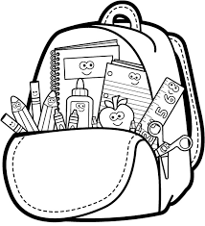**Kindergarten**

**Supply List**

Needed:

* Backpack
  + Large enough to hold a 9x12 folder
* Earphones
  + Packaging removed
  + Labeled with child’s name
  + Place in a zip-loc bag (labeled with child’s name)
* District issued iPad
  + already set up, logged on, and charged
* and remember to bring your BIG SMILES 😊

Nice to Have: (optional)

* 3-4 black Expo dry erase markers
* 1 canister of disinfecting wipes
* 1 box of tissues
* Zip-Loc Baggies
  + Boys: Quart or Sandwich Sizes
  + Girls: Gallon or Snack Sizes